**Software Engineering Assignment**

**Prepared by – OM GANDHI**

**MODULE : 1**

**SE – Overview of IT Industry**

1. **What is software? What is software engineering?**

**Answer->**

* **Software :**
* Software is a set of instructions, data or programs used to operate a computer and execute specific tasks. In simpler terms, it tells a computer how to function.
* In a computer system, the software is basically a set of instructions or commands that tell a computer what to do. In other words, the software is a computer program that provides a set of instructions to execute a user’s commands and tell the computer what to do. For example like MS-Word, MS-Excel, PowerPoint, etc.
* A set of instructions used to provide a specific output to reduce human efforts which is called software.
* **Software Engineering :**
* Software can be developed by following some set of rules, the process is called software engineering.
* Software Engineering is the process of designing,developing, testing and maintaining software.It is a systematic and disciplined approach to software development that aims to create high-quality, reliable, and maintainable software.
* Software Engineering is mainly used for large projects based on software systems rather than single programs or applications.
* The main goal of Software Engineering is to develop software applications for improving quality, budget, and time efficiency.

1. **Explain types of software.**

**Answer->**

There are 5 types of software:

1. System software

2. Application software

3. Driver Software

4. Middleware

5. Programming Software

1. **System Software :**
   * System software is a set of computer programs that manages and controls a computer's applications and hardware.
   * No need to download, install and provided by the system.
   * For example Calculater , Calender , Notepad
2. **Application Software :**

* Application Software is a computer program that helps users perform specific tasks such as those related to productivity, communication, or creativity.
* Need to download and need to develop, update.
* For example Paint, Microsoft Office, Powerpoint

1. **Driver Software :**

* Driver Software is a set of files that allows a computer's operating system to communicate with hardware.
* Any software that needs to be installed with particular intent which is called driver software.(Additionally add in the system)
* For example Audio , Video Driver

1. **Middleware :**

* Middleware software that connects applications, databases, and tools together, allowing them to communicate and share data.
* Intermediate software between System Software and application software.
* For example Webserver

1. **Programming Software :**

* Programming software is a tool that allows programmers to write code that tells a computer how to perform tasks and solve problems.
* For example Compiler, Interpreter, Assembler

**3.** **What is SDLC? Explain each phase of SDLC.**

**Answer ->**

* **SDLC :**
* The Software Development Life Cycle (SDLC) is a structured process that enables the production of high-quality, low-cost software, in the shortest possible production time.
* SDLC (software development lifecycle) is the process that a software project follows and which consists of a detailed plan describing how to develop, maintain, replace, change or improve specific software.
* A step by step approach to develop any software/product within the time and within the budget by high quality product.

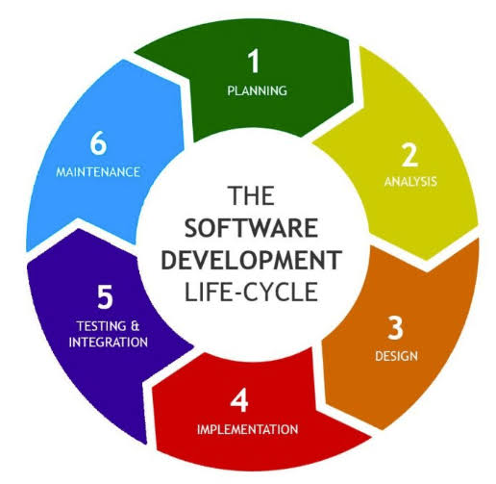

There are 6 Phases of SDLC.

1. Planning / Requirement Gathering

2. Analysis

3. Design (DFD, ER-Diagram, Flowchart, Usecase)

4. Implementation/Coding/Building (hardware/software)

5. Testing (QA-QC)

6. Maintenance

**1. Planning /Requirement Gathering :**

* The purpose of the first stage is to outline the scope of the problem and identify solutions. Resources, costs, time, and other aspects should be considered here.
* The planning phase of the SDLC is also when the project plan is developed that identifies, prioritizes, and assigns the tasks and resources required to build the structure for a project.

**2. Analysis :**

* This phase involves gathering information about the software requirements from stakeholders, such as customers, end-users, and business analysts.
* In the analysis phase, the development team works closely with the client. It involves understanding the client's needs and identifying their problems.
* This helps them understand the objectives and requirements of the business developers to get into the technical specifications. This helps them in the development process.

**3. Design :**

* In this phase, the software design is created, which includes the overall architecture of the software, data structures, and interfaces.
* In this phase when the database specification is developed to decide on data management and storage for future processing, retrieval, or evaluation.
* It has two steps:

**1.High-level design (HLD):** It gives the architecture of software products.

**2.Low-level design (LLD):** It describes how each and every feature in the product should work and every component.

**4. Implementation :**

* The design is then implemented in code, usually in several iterations, and this phase is also called as Development.
* This phase consists of Front end + Middleware + Back-end. This is the longest phase in SDLC model.
* During this software development lifecycle phase, clients will be able to have a first look at your future product. And by the end of the building process, clients will have an operating feature to share with the customers.

**5. Testing :**

* In the fifth phase,all the pieces of code are tested to verify and validate a software product.Testers then perform Software Testing Life Cycle activities to monitor the system for bugs and defects.This is done to check the correspondence between the real and expected behavior of a program.
* The testing stage and the initial SDLC phases can be performed with both internal software development and outsourcing, as they require end-user interaction.

**6. Maintenance :**

* Once the system is deployed, any necessary upgrades, enhancements and changes can be made, implementing new features into the operating software.It is crucial to maintain and modernize the system regularly so it can adapt to future needs.

**4. What is DFD? Create a DFD diagram on Flipkart**

**Answer ->**

* **Data Flow Diagram(DFD) :**
* A data flow diagram (DFD) is a visual representation of how data moves through a system, such as an information system or business process. DFDs are used to model the flow of data, including how it's input, processed, stored, and output.
* Data flow diagrams are made up of standardized symbols and notations, such as rectangles, circles, arrows, and short text labels.
* DFDs are useful for:

1. Improving efficiency: DFDs can help identify inefficiencies and opportunities for improvement.
2. Mapping systems: DFDs can be used to map out existing systems or plan new ones.
3. Visualizing data movement: DFDs help visualize how data moves through a system, which can lead to better decision-making and communication.

* **Some basic elements of a data flow diagram:**

1. **Processes**
2. **Data Flow**
3. **Data Store**
4. **External entities**

* **Overview of the Process**

**Processes Involved** :

1. **Customer Registration** : Customer registers to the Flipkart Portal.
2. **Add to Cart**: Customer adds a product to the add to cart.
3. **Add to Wishlist**: Customer adds a product to a wishlist for future reference.

**External Entities** :

1. **Customer**: The user who interacts with the portal by registering, adding products to cart, and adding products to wishlist.
2. **Admin**: The portal administrator who manages customer information, cart, and wishlist reports.

**Data Stores :**

1. **Customer DB**: Stores registered customer information.
2. **Cart DB:** Stores the list of products added to the cart.
3. **Wishlist DB:** Stores the wishlist products.
4. **Product DB:** Contains product information.

1. **Level 0 DFD (Context Diagram) :**

#### ****Entities**** :

* **Customer**: Registers, adds product to cart, and adds product to wishlist.
* **Admin**: Monitors the data, generates reports.
* **Processes** :
* **Flipkart** : The entire portal that handles customer registration, adding to cart, and add to wishlist.
* **Data Flow** :
* **Customer → Portal**: Customer Registration, Add to Car, Add to Wishlist
* **System → Customer**: Registration Confirmation, Add to Cart Confirmation, Add to Wishlist Confirmation
* **Admin → System**: Mobile Stock Update, Sales Report Request
* **System → Admin**: Customer List, Sales Report
  1. **: Data flow diagram level 0 diagram**

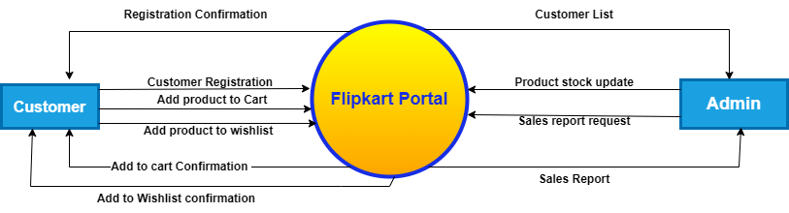

1. **Level 1 DFD :**

* **Entities :**
* **Customer**: The user who performs actions like registration, adding products to the cart, or adding products to the wishlist.
* **Admin**: The administration who accesses and manages the portal, including customer details, cart, wishlist data, review reports.
* **Processes :**
* **Customer Registration**: Handles the customer's registration and stores their data in the **Customer DB**.
* **Add to Cart**: Manages products to the shopping cart and stores the details in the **Cart DB**.
* **Add to Wishlist**: Manages adding products to the wishlist and stores the wishlist data in the **Wishlist DB.**
* **Admin Management**: Admin monitors and updates customer information, stock, and generates reports.
* **Data Stores :**
* **Customer DB**: Stores customer registration data.
* **Cart DB**: Stores details of the products added to the cart.
* **Wishlist DB**: Stores products that are added to the wishlist.
* **Product stock DB**: Stores the details of the available mobile phones.

#### ****Data Flows**** :

* **Customer → Customer Registration Process**: Customer sends registration information.
* **Customer Registration Process → Customer DB**: Stores customer information in the database.
* **Customer → Add to Cart Process**: Adds selected products to the cart.
* **Add to Cart Process → Cart DB**: Stores cart data in the database.
* **Customer → Add to Wishlist Process**: Adds selected products to the wishlist.
* **Add to Wishlist Process → Wishlist DB**: Stores wishlist data in the database.
* **Add to Wishlist DB → Add to Cart Process**: Transfer whishlist product
* **Customer DB → Admin Management:** Retrieve customer information for customer report.
* **Cart DB → Admin Management**: Retrieve cart information for cart report.
* **Wishlist DB Review → Admin Management**: Retrieve wishlist information for wishlist report.
* **Admin → Admin Management**: Product stock and management .
* **Admin Management → Product stock DB:** Stock updates.
* **Product stock DB → Admin Management : Retrieve Stock inf.**
* **Admin Management → Admin**: Processed information (reports and updates).

**2.1 : Data flow diagram level 1 diagram**

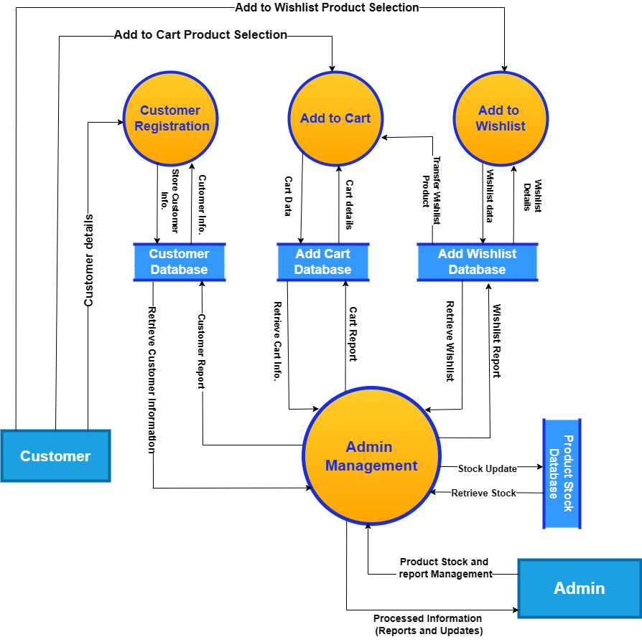

1. **Level 2 DFD :**

* **Entities** **(External) :**

1. **Customer**: Registers, adds products to cart and wishlist.
2. **Admin**: Accesses the portal for reports and management.

#### ****Processes**** (Internal system processes) :

1. **Customer Registration**
2. **Add to Cart**
3. **Add to Wishlist**
4. **Admin Management**

#### ****Data Stores**** :

#### ****Customer DB****: Stores registered customer details.

#### ****Cart DB****: Stores products added to the cart.

#### ****Wishlist DB****: Stores products added to the wishlist.

#### ****Product Stock DB****: Stores product data.

### ****3(A). Customer Registration Breakdown (Level 2 DFD)****

### ****Entities**** :

### ****Customer****

### ****Admin****

### ****Processes**** :

### ****Validate Information****: The portal checks whether the provided details are valid.

### ****Create Customer Account****: The **validated customer data and new customer record** are stored in the **Customer Database**.

### ****Generate Customer Report:**** Once the customer account is created, a **Customer Report** is generated and sent to the **Admin** for monitoring or approval.

### ****Data Stores**** :

### ****Customer DB****

### ****Data Flow**** :

### ****Customer Registration Details**** (from **Customer** → **Validate Customer Data**).

### ****Validated Data**** (from **Validate Customer Data** → **Create Customer Account**).

### ****Customer Record**** (from **Create Customer Account** → **Customer Database**).

### ****Customer Report**** (from **Generate Customer Report** → **Admin**).

### ****3(A.1). Customer Registration Breakdown Diagram (Level 2 DFD)****

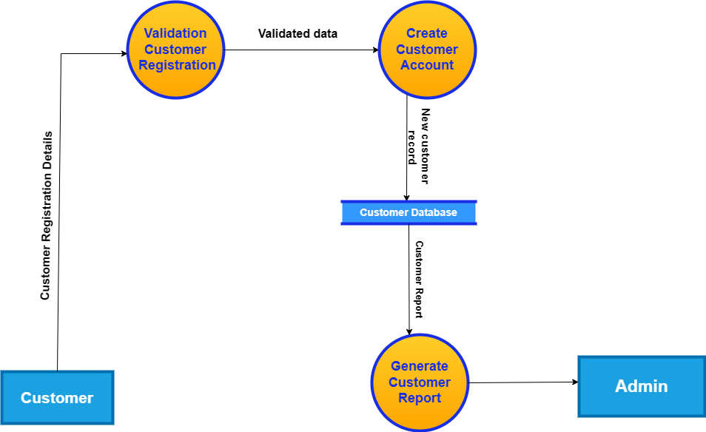

### ****3(B). Add to Cart Breakdown (Level 2 DFD)****

* **Processes** :
* **Display Product Catalog:** The product catalog is pulled from the **Product Stock Database** and displayed to the **Customer.**
* **Select Product**: Customer selects a product to add to the cart.
* **Add Product to Cart**: If available, the product is added to the **Cart DB**.
* **Update Cart Quantity:** If the customer adds more of the same product, the **quantity is updated** in the **Cart Database.**
* **Data Stores** :
* **Product DB**
* **Cart DB**
* **Data Flow** :
* **Product Catalog** (from Product Stock Database → Display Product Catalog).
* **Selected Product** (from Display Product Catalog → Select Product).
* **Product to Cart** (from Select Product → Add Product to Cart).
* **Updated Cart Quantity** (from Add Product to Cart → Update Cart Quantity → Cart Database).

### ****3(B.1). Add to Cart Breakdown Diagram (Level 2 DFD)****

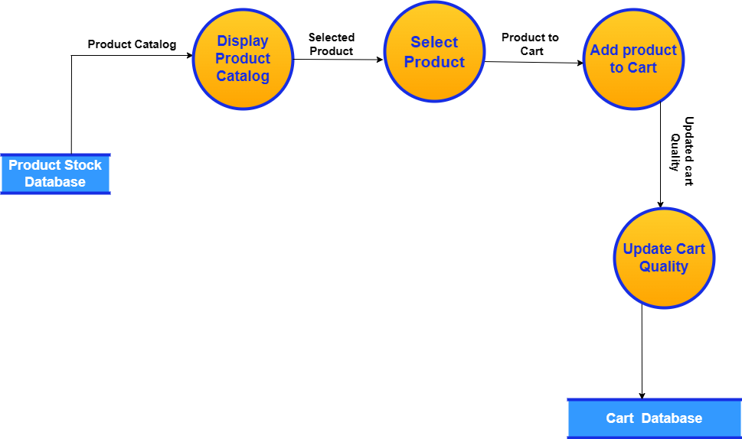

### ****3(C). Add to Wishlist Breakdown (Level 2 DFD)****

* **Processes** :

1. **Display Product Catalog:** The product catalog is pulled from the **Product Stock Database** and displayed to the **Customer.**
2. **Select Product for Wishlist**: Customer chooses a product to add to the wishlist.
3. **Add Product to Wishlist**: The product is added to the **Wishlist DB**.

* **Data Stores** :
* **Product DB**
* **Wishlist DB**
* **Data Flow** :

1. **Product Catalog** (from Product Stock Database → Display Product Catalog).
2. **Selected Wishlist Product** (from Display Product Catalog → Select Product for Wishlist).
3. **Product to Wishlist** (from Select Product for Wishlist → Add Product to Wishlist → Wishlist Database).

### ****3(C.1)Add to Wishlist Breakdown Diagram(Level 2 DFD)****

### C:\TOPS OM GANDHI\Assignment\Answer\SE Assignment Module\Images\DFD\Level 2 (C.1)Diagram.drawio.png

### ****3(D). Admin Access (Review Reports) Breakdown (Level 2 DFD)****

* **Entities**:
* **Admin**
* **Processes** :

1. **View Customer Reports**: The **Customer Database** provides the admin with customer details (names, orders, etc.).
2. **Update Product Stock**: The **Admin** adds new stock or updates existing stock in the Product **Stock Database.**
3. **Generate Sales Report**: he sales report is generated by combining information from the **Cart Database** and the **Product Stock Database**.
4. **Manage Customer Data**: The **Admin** can update customer records, which are then saved to the **Customer Database.**

* **Data Stores** :
* **Customer DB**
* **Product DB**
* **Data Flow** :

1. **Customer Reports** (from Customer Database → View Customer Reports → Admin).
2. **Stock Update** (from Admin → Update Product Stock → Product Stock Database).
3. **Sales Report** (from Cart Database and Product Stock Database → Generate Sales Report → Admin).
4. **Customer Data Management** (from Admin → Manage Customer Data → Customer Database).

### ****3(D.1). Admin Access (Review Reports) Breakdown Diagram (Level 2 DFD)****

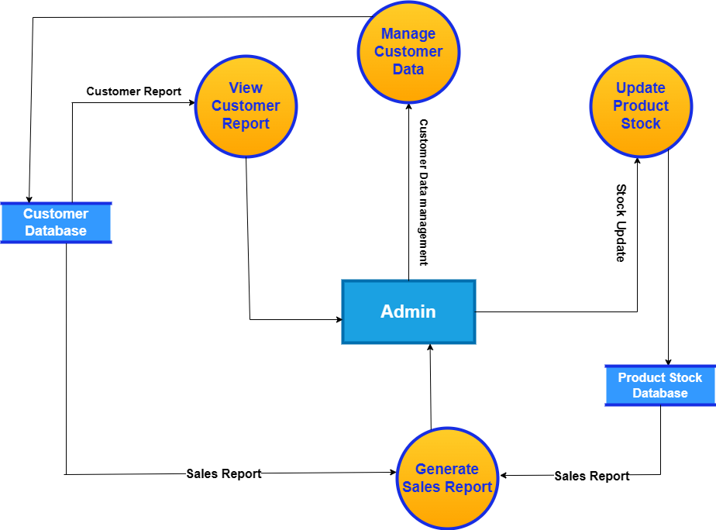

**5. What is Flow chart? Create a flowchart to make addition of two numbers**

**Answer :**

* **Flowchart :**
* A diagram that shows step-by-step progression through a procedure or system especially using connecting lines and a set of conventional symbols which is called flowchart.
* **Flowcharts can help with:**
* Identifying essential steps
* Understanding the bigger picture
* Finding bottlenecks, flaws, and unnecessary steps
* Improving efficiency
* Organizing tasks in chronological order
* Identifying tasks by type

A flowchart is a diagram that shows the steps, sequences, and decisions of a process or workflow. Flowcharts are used to visualize, document, and improve processes, and are a fundamental tool for process analysis.

**5.1 Flowchart to make addition of two numbers**

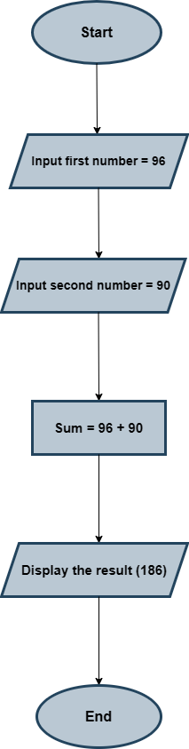

**6. What is Use case Diagram? Create a use-case diagram in bill payment on Paytm**

**Answer –**

* **Use Case Diagram :**
* A use case diagram is a graphical depiction of a user's possible interactions with a system.It's a key tool in the early stages of system design and development to help ensure everyone involved understands how the system will work.
* **Use case diagram can help with:**
* Defining requirements: Helps define and organize functional requirements.
* Specifying context: Helps specify the context and requirements of a system.
* Modeling events: Helps model the basic flow of events in a use case.
* Understanding capabilities: Helps everyone involved understand the system's capabilities and interactions.
* **Components of use case diagram :**

1. Actors
2. The system itself
3. Use cases
4. Associations

**1. Actors :**

* **User**: The customer who uses Paytm to logging in, viewing bills, selecting a bill, making payments, and checking the payment status.
* **Bank**: Handles the financial transaction and payment request from Paytm.
* **Bill Provider**: The service provider or company receiving the payment for the bill.

**2. System :**

* **Paytm System**: The system responsible for managing the interactions between the user, the bank, and the bill provider. It handles user actions and processes payments.

**3. Use Cases :**

* **Login**: The user logs into the Paytm system to initiate the payment process.
* **View Bills**: The user views all available bills.
* **Select Bill**: The user selects a specific bill for payment.
* **Payment**: The user initiates the payment process for the selected bill.
* **Process Payment**: The Paytm system processes the payment by interacting with the bank and bill provider.
* **Confirm Transaction**: The Paytm system confirms the transaction once the payment is successfully processed.
* **Check Payment Status**: The user checks the status of their payment.

**4. Associations :**

* **User Interactions**:
* The user interacts with the Paytm system to log in, view bills, select a bill, initiate payment, and check payment status.
* The user receives a confirmation once the payment is successfully processed.
* **System-Bank Interaction**:
* After initiating payment, the Paytm system requests payment processing from the bank.
* The bank confirms the payment back to the system.
* **System-Bill Provider Interaction**:
* The Paytm system sends the payment details to the bill provider after confirming with the bank.
* The bill provider confirms the receipt of the payment back to the system.

**6.1 Use-case diagram on bill payment on Paytm**

